**Getting started with MySQL installation and configuration can be split into 3 steps:**

1. **Downloading MySQL Installer**
2. **Installing and configuring MySQL**
3. **Getting started with MySQL using powerful GUI tool called Workbench**

**Let’s begin with the step 1 – Downloading MySQL Installer**

**You can find MySQL Installer for Windows from the official MySQL website at**[**http://www.mysql.com/**](http://www.mysql.com/)**or you can go directly to**[**http://dev.mysql.com/downloads/**](http://dev.mysql.com/downloads/)**.**

**Browse to the**[**http://dev.mysql.com/downloads/**](http://dev.mysql.com/downloads/)**link and you will get the following screen.**

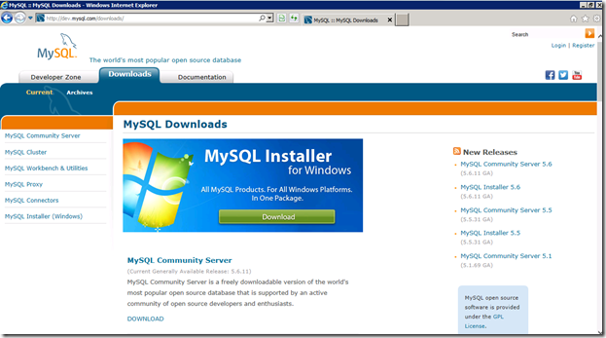

**You can choose to install every component separately, but for Windows Server I would suggest downloading MySQL Installer for Windows. It will install everything you may need to run MySQL and that is:**

**– MySQL Server**

**– All support connectors**

**– Workbench and sample models**

**– MySQL Notifier**

**– MySQL for Excel**

**– MySQL for Visual Studio**

**– Sample databases**

**– Documentation**

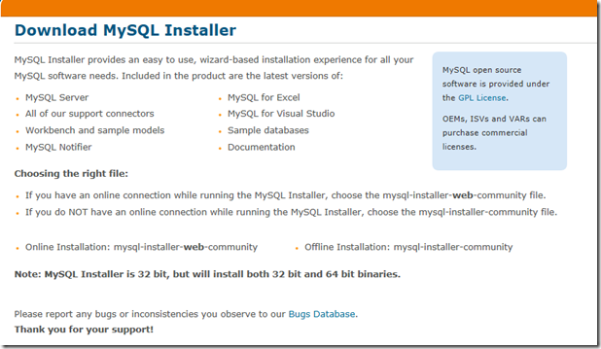

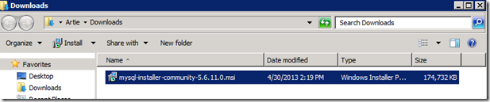

**Now when we have the installer downloaded we can move on to step 2- Installing and configuring MySQL**

**Start with double clicking the MSI file.**

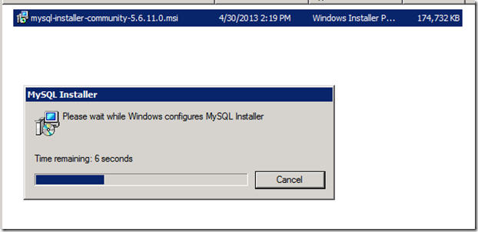

**Once the MySQL Installer installation wizard opens, click on Install MySQL Products and read and accept the license terms.**

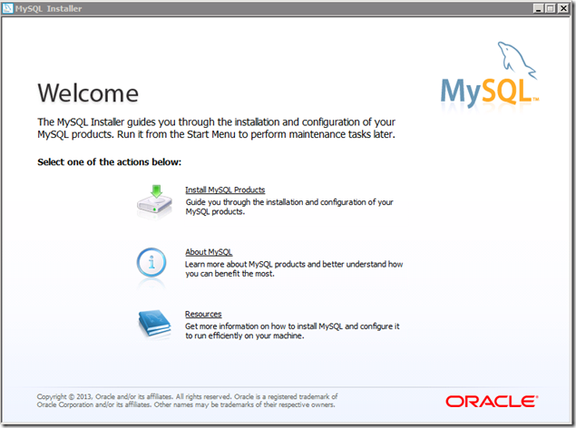

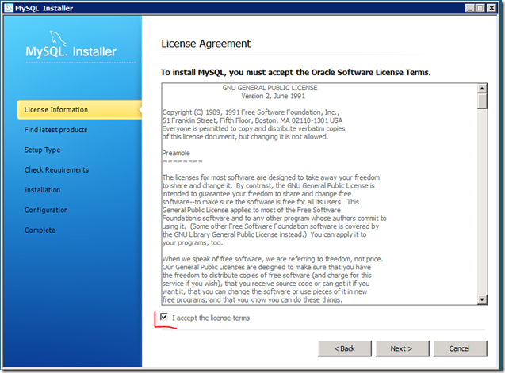

**After you read and accepted the license terms, click Next and the wizard will ask you to check for updates. Although I just downloaded the installer, it is still worth checking if any updates are available, so I do not ‘Skip the check for updates’ and click Execute.**

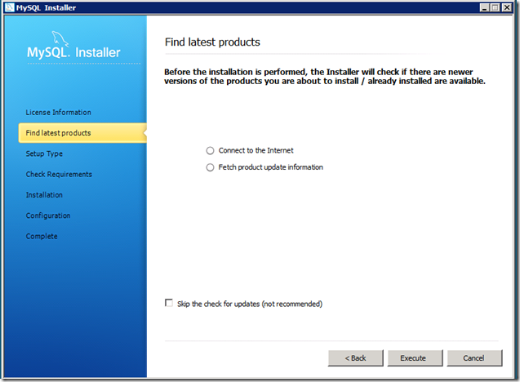

**Once the check has been completed, click Next.**

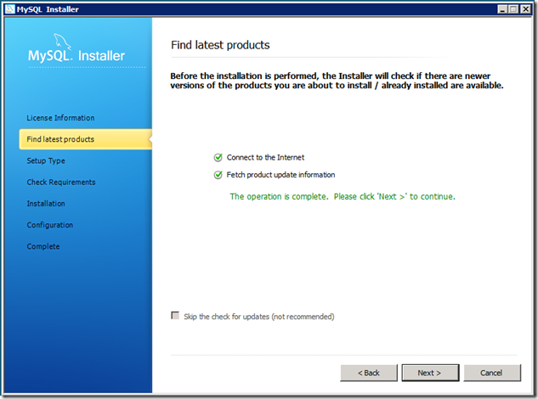

**Now the configuration process begins. First we need to choose our Setup Type. There are 5 options we can choose from:**

* **Developer Default**
* **Server only**
* **Client only**
* **Full**
* **Custom**

**Since we’re installing MySQL on our Dedicated server (whether a Physical or Cloud Server) and we will be developing our applications on this server, we will go with the default setup type, namely Developer Default.**

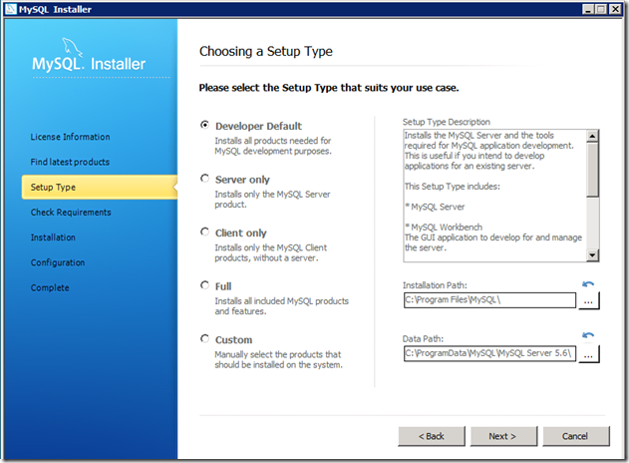

***Note:* Before you click Next, pay attention to the Installation Path and Data Path. It is OK to leave them to their default locations, but it’s good to know where MySQL is installed (the Installation Path) and where the data will be stored (Data Path).**

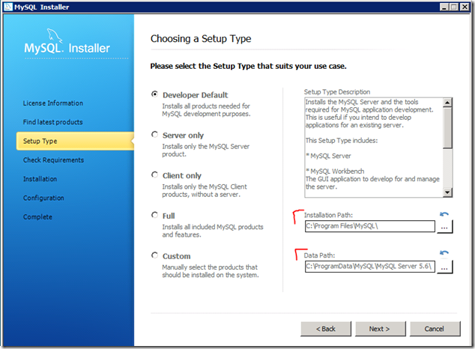

**Now you can click Next and move on to the next screen. You will see all the system requirements listed here. The ones installed will have a green check mark on the list and the ones needed and not installed will have the check boxes empty. When you Execute from here the required, though not installed components will be installed.**

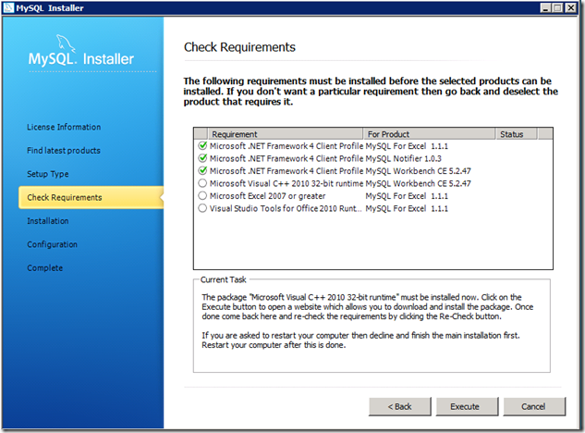

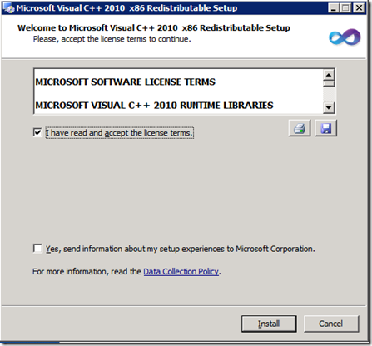

**After installing the required component, in my case, Microsoft Visual Studio C++ 2010, the requirements list will be displayed again and you can move to the next part from here.**

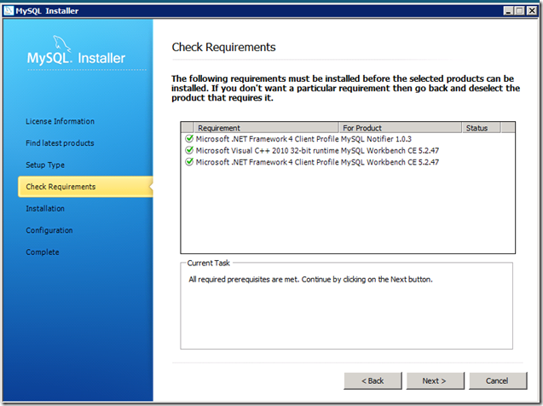

**Now, when all required components have been installed we can proceed with MySQL Products installation. Click Next.**

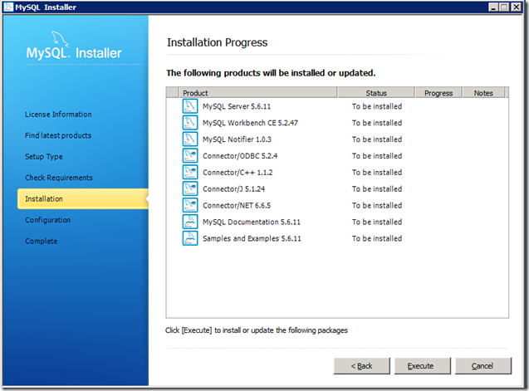

**Before you execute the installation process, just pay attention to how fast the process is.**

**After installation we need to configure MySQL. This is a very important step, luckily it’s very simple with MySQL Installer. Click Next to proceed with MySQL Server configuration.**

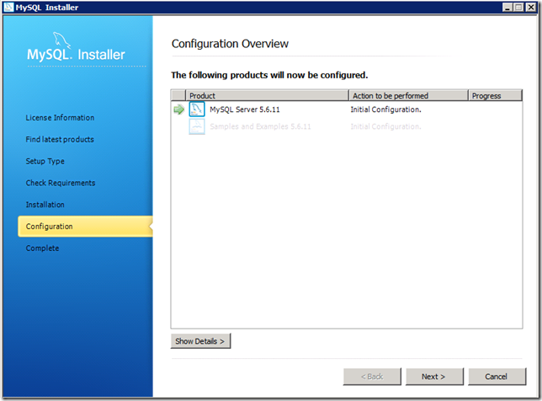

**At this point you need to choose your MySQL configuration type. The MySQL Installer Wizard defaults to Development Machine. In my case, I’m installing it on a Server that will run other applications as well, so it’s not a Dedicated MySQL Server. For this reason, I’m going to choose Server Machine.**

**I will leave the other settings as they are by default, with TCP/IP Networking enabled on the default MySQL server port 3306 and will proceed.**

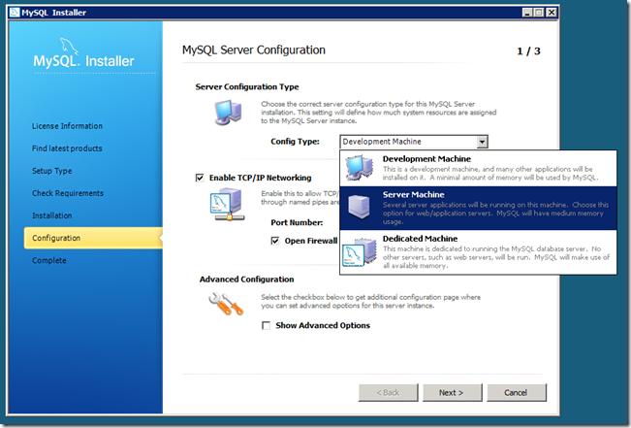

**The MySQL administrative user name is root and we don’t have an option to change it, but we need to provide a complex password for this user. Conveniently enough, the Installer will validate the password complexity and will let us know if it’s weak or strong.**

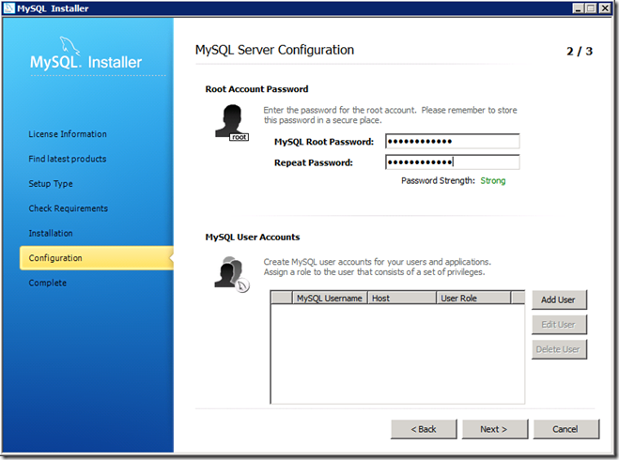

**In addition to the root user, we can add our own user at this point, so I’m going to do it right now.**

**I will leave the Host and Role set to default so my new user will have DB Admin role assigned.**

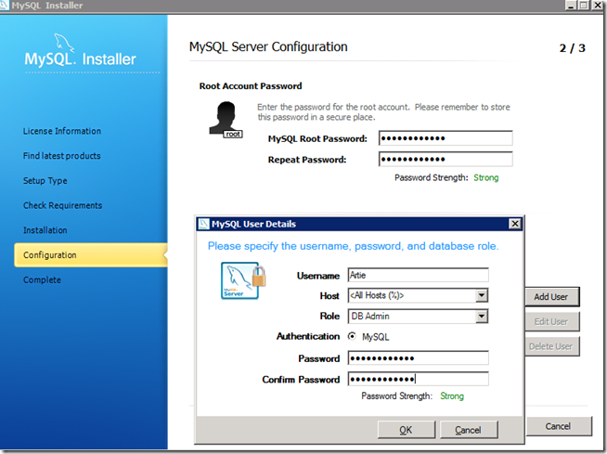

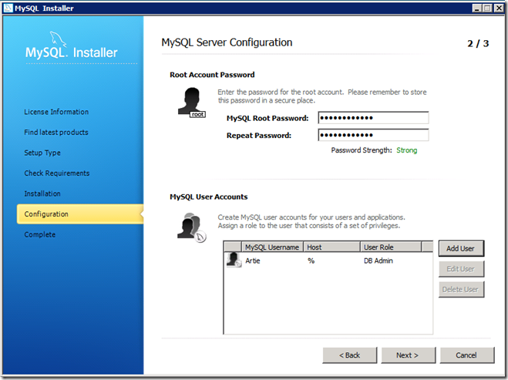

**After setting a complex password for the root user and adding my own DB Admin user, I’m going to go to the next screen to complete MySQL Server configuration.**

**Now I have a chance to configure Windows Server Details and edit Windows Service Name to easily identify the service.**

**I will name mine MySQLMain and click Next.**

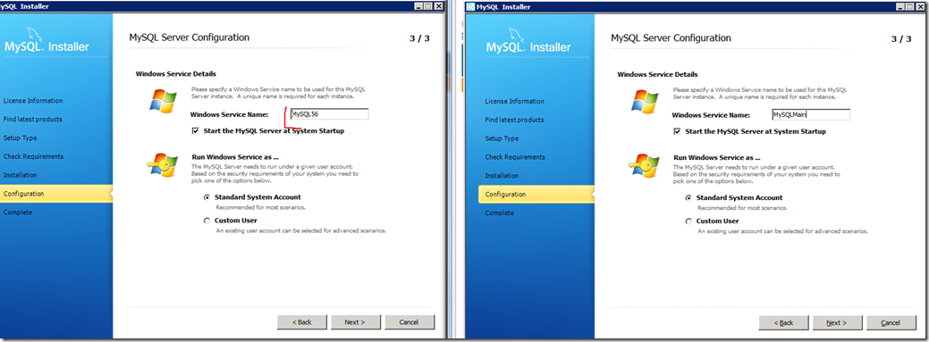

**Now server configuration is completed and we can configure samples and examples.**

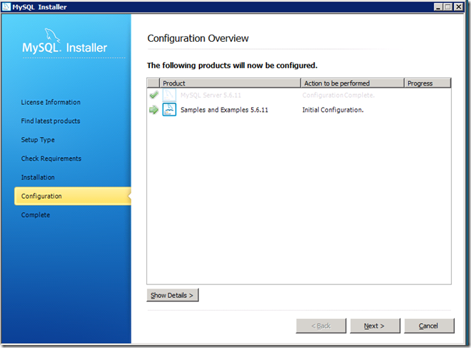

**After clicking Next, MySQL server and Samples and Examples are fully installed and configured**

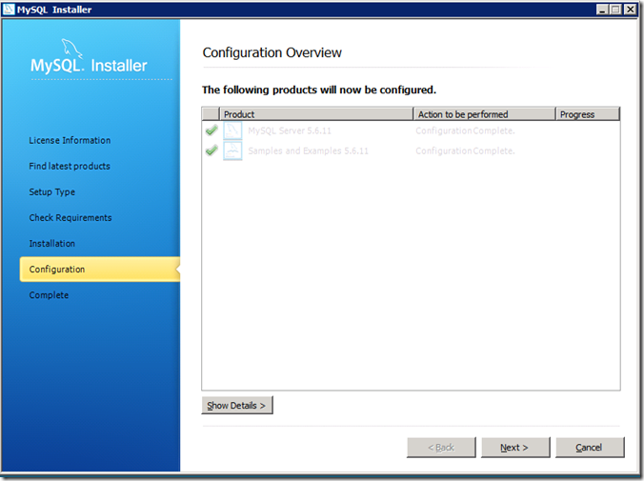

**Click Next and your MySQL Server installation and configuration process is completed.**

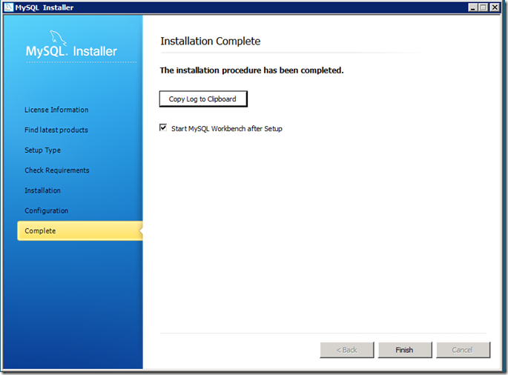

**Once you click Finish, MySQL Workbench will start up and will be ready for you.**

**This is the step 3- Getting started with MySQL using powerful GUI tool called Workbench**

**[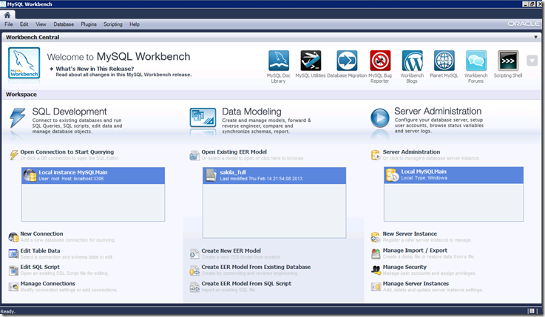](https://images.sherweb.com/OrcsWeb/2013/05/clip_image0241.png)**

**MySQL Workbench is a powerful GUI for managing MySQL and will be covered in another post.**